CONSISTENCY AS A SERVICE:

AUDITING CLOUD CONSISTENCY

INTRODUCTION:
Modern cloud auditing has been studied for past 5years. Cloud storage services can be responsible as a typical service in cloud computing, which involves the delivery of data storage as a service, including database-like services and network attached storage, often billed on a utility computing basis, e.g., per gigabyte per month. Examples include Amazon SimpleDB1, Microsoft Azure storage2, and so on. By using the cloud storage services, the customers can access data stored in a cloud anytime and anywhere, using any device, without caring about a large amount of capital investment when deploying the underlying hardware infrastructures.

OBJECTIVE OF THE PROJECT
The objective of our project for consistency is to define auditing structures and secure to allow read and write operation in cloud computational domain with no violation and less severity for a generic scenario.

SCOPE OF THE PROJECT
The main theme or scope of the project is the application which will easy to integrate with multiple servers and even it will maintain the consistency under replication. Results will be very accurate and effiency and easily trace all users operation finally it will produce very strong consistency.

LITERATURE SURVEY
TITLE : Data consistency properties in Amazon SimpleDB and Amazon S3
AUTHOR : Davide Gerhard, Davide Girardi
YEAR : 2012-11.
DESCRIPTION
The new services offered by the commercial cloud storage systems are attracting a lot of interest nowadays for their ability to offer scalability, availability and durability at a low cost. The other side of the medal of these systems is usually their weak consistency properties, considering the theorems behind distributed systems, such as the CAP theorem. During our work, we analyzed two of these services, Amazon SimpleDB and Amazon S3, from a consumer perspective in order to understand which kinds of consistencies they really offer and if they respect what is promised. As a starting point, we focused on the research done by Hiroshi Wada, Alan Fekete, Liang Zhao, Kevin Lee and Anna Liu, described in [2], trying to reproduce their results.

TITLE : Dynamo: Amazon’s Highly Available Key-value Store
AUTHOR : Giuseppe DeCandia, Deniz Hastorun
YEAR : OCT 2007.
DESCRIPTION
Reliability at massive scale is one of the biggest challenges we face at Amazon.com, one of the largest e-commerce operations in the world; even the slightest outage has significant financial consequences and impacts customer trust. The Amazon.com platform, which provides services for many web sites worldwide, is implemented on top of an infrastructure of tens of thousands of servers and network components located in many datacenters around the world. At this scale, small and large components fail continuously and the way persistent state is managed in the face of these failures drives the reliability and scalability of the software systems.

TITLE : Data Consistency Properties and the Trade offs in Commercial Cloud Storages
AUTHOR : Hiroshi Wada_ y, Alan Feketez, Liang Zhaoy
YEAR : 2011.
DESCRIPTION
A new class of data storage systems, called NoSQL (Not Only SQL), has emerged to complement traditional database systems, with rejection of general ACID transactions as one
Common feature. Different platforms, and indeed different primitives within one NoSQL platform, can offer various consistency properties, from Eventual Consistency to single-entity ACID. For the platform provider, weaker consistency should allow better availability, lower latency, and other benefits. This paper investigates what consumers observe of the consistency and performance properties of various offerings. We find that many platforms seem in practice
to offer more consistency than they promise; we also find cases where the platform offers consumers a choice between stronger and weaker consistency, but there is no observed benefit from accepting weaker consistency properties.

TITLE : Quality-of-Data for Consistency Levels in Geo-replicated Cloud Data Stores
AUTHOR : Álvaro García-Recuero , Sérgio Esteves
YEAR : 2011
DESCRIPTION
Provide individuals and companies with access to remote computing and storage infrastructures. In order to achieve highly-available yet high-performing services, cloud data stores rely on data replication. However, providing replication brings with it the issue of consistency. Given that data are replicated in multiple geographically distributed data centers, and to meet the increasing requirements of distributed applications, many cloud data stores adopt eventual consistency and therefore allow to run data intensive operations under low latency. This comes at the cost of data staleness. In this paper, we prioritize data replication based on a set of flexible data semantics that can best suit all types of Big Data applications, avoiding overloading both network and systems during large periods of disconnection or partitions in the network.

TITLE : Distributed Computing in Practice: The Condor Experience
AUTHOR : Douglas Thain, Todd Tannenbaum, and Miron Livny
YEAR : 2012.
DESCRIPTION
Ready access to large amounts of computing power has been a persistent goal of computer scientists for decades., visions of computing utilities as pervasive and as simple as the telephone have driven users and system designers. It was recognized in the that such power could be achieved inexpensively with collections of small devices rather than expensive single supercomputers.

TITLE : Client-centric Benchmarking of Eventual Consistency for Cloud Storage Systems
AUTHOR : Badrul Sarwar, George Karypis, Joseph Konstan, and John Riedl.
YEAR : 2010.
DESCRIPTION
Eventually-consistent key-value storage systems sacrifice the ACID semantics of conventional databases to achieve superior latency and availability. However, this means that client applications, and hence end-users, can be exposed to stale data. The degree of staleness observed depends on various tuning knobs set by application developers (customers of key-value stores) and system administrators (providers of key-value stores). Both parties must be cognizant of how these tuning knobs affect the consistency observed by client applications in the interest of both providing the best end-user experience and maximizing revenues for storage providers. Quantifying consistency in a meaningful way is a critical step toward both understanding what clients actually observe, and supporting consistency-aware service level agreements (SLAs) in next generation storage systems.

TITLE : Improving Audit Judgment and Decision Making With Dual Systems Cognitive Model
AUTHOR : Badrul Philip Yim Kwong Cheng
YEAR : 2010.
DESCRIPTION
The remainder of the paper is organized as follows. We first explain how the heuristics of availability, representativeness, and anchoring-and-adjustment could have unfavourable impact on auditors’ judgment and decisions, followed by discussions of recency and dilution effects. We then introduce the properties of the two systems of reasoning put forward by cognitive scientists, referred to System 1 and System 2 hereon in the article. Against this background, we propose and illustrate with examples an easily implemented dual systems cognitive model. We conclude our paper with a few directions for future research in a new frontier of behavioral audit research.

TITLE : A Loop Correlation Technique to Improve Performance Auditing
AUTHOR : Jeremy Lau, Matthew Arnold, Michael Hind.
YEAR : 2010.
DESCRIPTION
Performance auditing is an online optimization strategy that empirically measures the effectiveness of an optimization on a particular code region. It has the potential to greatly improve performance and prevent degradations due to compiler optimizations. Performance auditing relies on the ability to obtain sufficiently many timings of the region of code to make statistically valid conclusions. This work extends the state-of-the-art of performance auditing systems by allowing a finer level of granularity for obtaining timings and thus, increases the overall effectiveness of a performance auditing system. The problem solved by our technique is an instance of the general problem of correlating a program’s high-level behavior with its binary instructions, and thus, can have uses beyond a performance auditing system. We present our implementation and evaluation of our technique in a production Java VM.

MODULES
1. User interface
2. Read and Write Operations
3. Genarating UOT Table
4. Local and Global Auditing
5. Performance Evaluation

MODULE DESCRIPTION
1. User Interface Design:
To connect with server user must give their username and password then only they can able to connect the server. If the user already exits directly can login into the server else user must register their details such as username, password and Email id, into the server. Server will create the account for the entire user to maintain upload and download rate. Name will be set as user id. . Logging in is usually used to enter a specific page.

2. Read and Write Operations
Each operation op is either a write W(K, a) or a read R(K, a), where W(K, a) means writing the value a to data that is identified by key K, and R(K, a) means reading data that is identified by key K and whose value is a. As we call W(K, a) as R(K, a)’s dictating write, and R(K, a) as W(K, a)’s dictated read. We assume that the value of each write is unique. This is achieved by letting a user attach his ID, and current vectors to the value of write. Therefore, we have the following properties: (1) a read must have a unique dictating write. A write may have zero or more dictated reads. (2) From the value of a read, we can know the logical and physical vectors of its dictating write.

3. Generating UOT Table
Each user maintains a UOT for recording local operations. Each record in the UOT is described by three elements: operation, logical vector, and physical vector. While issuing an operation, a user will record this operation, as well as his Current logical vector and physical vector, in his UOT. Each operation op is either a write W (K, a) or a read R (K, a), where W(K, a) means writing the value a to data That is identified by key K, and R(K, a) means reading data that is identified by key K and whose value is a. As, we call W (K, a) as R(K, a)’s dictating write, and R(K, a) as W(K, a)’s dictated read. We assume that the value of each write is unique. This is achieved by letting a user attach his ID, and current vectors to the value of write. Therefore, we have the following properties: (1) A read must have a unique dictating write. A write may have zero or more dictated reads. (2) From the value of a read, we can know the logical and physical vectors of its dictating write.

4. Local and Global Auditing
Local Auditing:
Local consistency auditing is an online algorithm, each user will record all of his operations in his UOT. While issuing a read operation, the user will perform local consistency auditing independently. Let R(a) denote a user’s current read whose dictating write is W(a), W(b) denote the last write in the UOT, and R(c) denote the last read in the UOT whose dictating write is W(c). Read-your-write consistency is violated if W(a) happens before W(b), and monotonic-read consistency is violated if W(a) happens before W(c). Note that, from the value of a read, we can know the logical vector and physical vector of its dictating write. Therefore, we can order the dictating writes by their logical vectors.
Global Auditing
Global consistency auditing is an offline algorithm. Periodically, an auditor will be elected from the audit cloud to perform global consistency auditing. In this case, all other users will send their UOTs to the auditor for obtaining a global trace of operations. After executing global auditing, the auditor will send auditing results as well as its vectors to all other users. Given the auditor’s vectors, each user will know other users’ latest clocks up to global auditing.

5. Performance Evaluation
We summarize the parameters used in the synthetic violation traces in Table II. In the random strategy, we randomly choose [1, l] auditing reads in each interval, where l is the Length of an interval. To obtain the synthetic violation traces, physical time is divided into 2,000 time slices. We assume that once a data cloud begins to violate the promised consistency, this violation will continue for several time slices, rather than ending immediately. In the simulation, the duration of each violation d is set to 3-10 time slices.

MODULES DIAGRAM
1. User Interface Design:

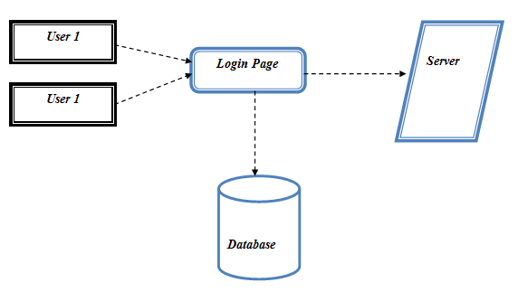

2. Read and Write Operations
USER 1
User Cloud Key
AMAZON CLOUD DRIVE
USER 2
User Cloud Key
AUDITOR

WRITE OP

READ OP

3. Generating UoT Table UOT
USER 1
User Cloud Key
AMAZON CLOUD DRIVE
USER 2
User Cloud Key
AUDITOR
Local vector

Global Vector

4. Local and Global Auditing

AUDITOR
UOT
Local Auditing
Global Auditing
USER 1
User Cloud Key
AMAZON CLOUD DRIVE
User Cloud Key
USER 2
CLOUD OWNER

5. Performance Evaluation
AUDITOR
UOT
Local Auditing
Global Auditing
USER 1
User Cloud Key
AMAZON CLOUD DRIVE
User Cloud Key
USER 2
CLOUD OWNER
PERFORMANCE EVALUATION

EXPECTED OUTPUT

1. User Interface Design:
Given Input : Username and Password.
Output : Display user home page.

2. Read and Write Operations
Given Input : Select File
Output : Download or Upload File.

3. Generating UoT Table
Given Input : Track all user operations.
Output : send to auditor.

4. Local and Global Auditing
Given Input : Local auditing data and global auditing data.
Output : send to auditing details to cloud owner.

5. Performance Evaluation
Given Input : algorithm parameters.
Output : Graph representation of algorithm performance.

Proposed System technique
LOCAL AUDITING:

Local consistency auditing is an online algorithm; each user will record all of his operations in his UOT. While issuing a read operation, the user will perform local consistency auditing independently.

Initial UOT with ∅
While issue an operation op does
If op = W (a) then
Record W (a) in UOT
If op = r (a) then
W (b) ∈ UOT is the last write
If W (a) → W (b) then
Read-your-write consistency is violated
R(c) ∈ UOT is the last read
If W (a) → W(c) then
Monotonic-read consistency is violated
Record r (a) in UOT

GLOBAL AUDITING:
Global consistency auditing is an offline algorithm periodically; an auditor will be elected from the audit cloud to perform global consistency auditing. In this case, all other users will send their UOTs to the auditor for obtaining a global trace of operation.

Each operation in the global trace is denoted by a ve
rtex
For any two operations op1 and op2 do
If op1 → op2 then
A time edge is added from op1 to op2
If op1 = W (a), op2 = R (a), and two operations come
From different users then
A data edge is added from op1 to op2
If op1 = W (a), op2 = W (b), two operations come from
Different users, and W (a) is on the route from W (b) to
R (b) then
A causal edge is added from op1 to op2
Check whether the graph is a DAG by topological sorting

REF PAPER : ”cognitive heuristics and biases in behavioral auditing: review, comments and observations”.

HARDWARE & SOFTWARE REQUIREMENTS

HARDWARE
PROCESSOR : PENTIUM IV 2.6 GHz, Intel Core 2 Duo.
RAM : 512 MB DD RAM
MONITOR : 15” COLOR
HARD DISK : 40 GB

SOFTWARE
Front End : JAVA (JSP SERVLET)
Back End : My SQL5.5
Operating System : Windows XP/07
IDE : Net Beans, Eclipse

SYSTEM DESIGN
USE CASE DIAGRAM

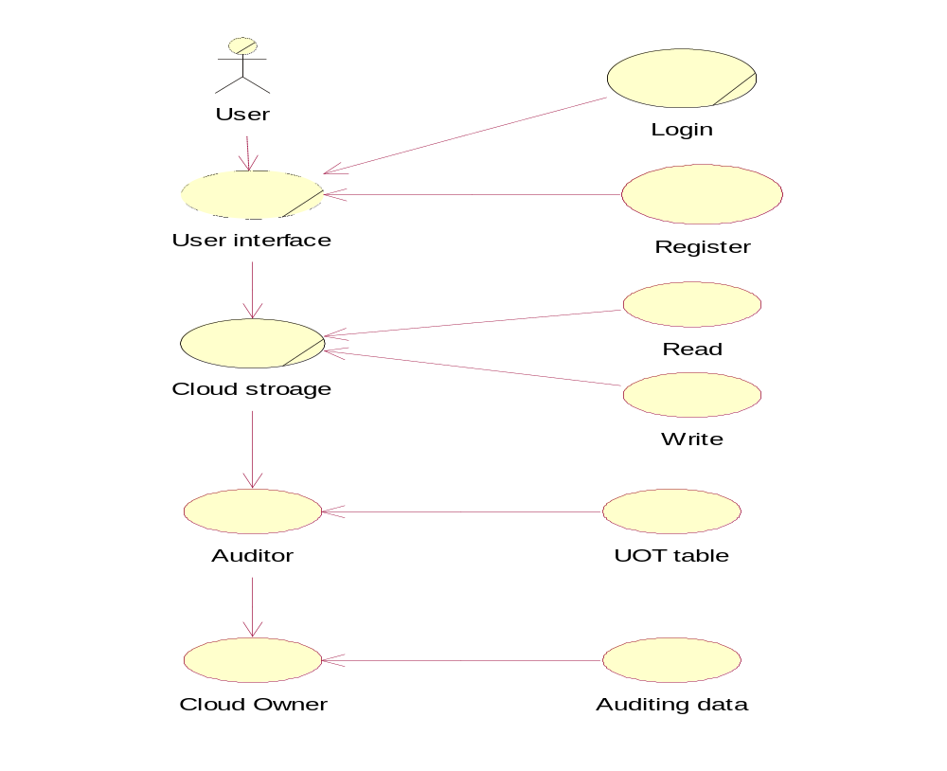

This is a type of behavioral diagram defined by and created from a Use-case analysis. Here a sender can send a packet it selects a dynamic path routing and then it send to receiver node and then if attacker is received they may be send or drop the packet. Thus here nodes and attacker is an actor. The packet may be sent or may not be sent. In this UML diagram we present a actor behavior or role in that project.

CLASS DIAGRAM

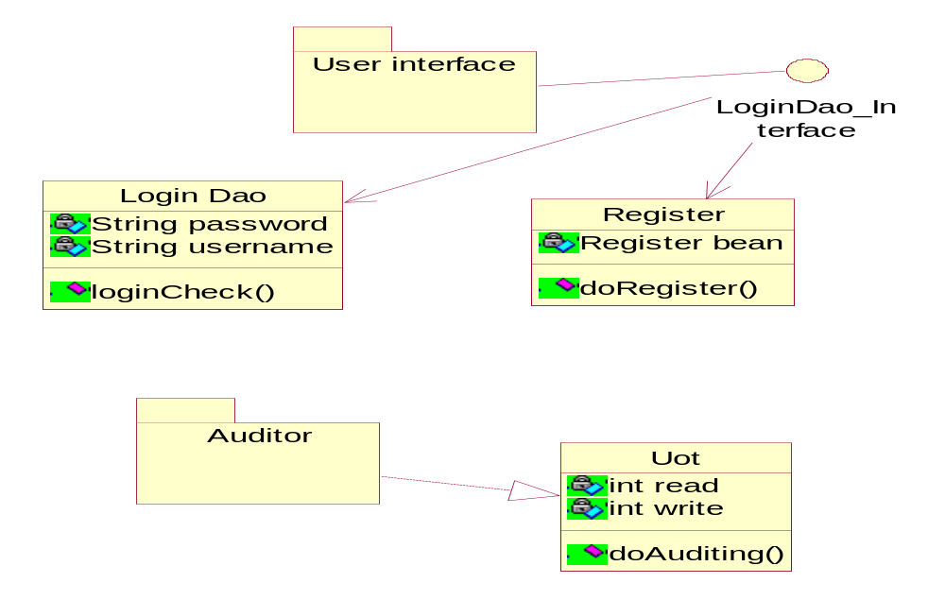

This type of static structure diagram that describes the structure of a system by showing the system’s classes, their attributes, operations (or methods), and the relationships among the classes. Here the node consists of ip address, port no, name. And then attacker also has same things. Then we find out the attacker and then predict our network.

OBJECT DIAGRAM

Query
Auditing
Cloud
Local Auditing
Local Auditing

Cloud Owner

An Object diagram focuses on some particular set of object instances and attributes, and the links between the instances. Here we create an object for node selection and attacker node for receiving and sending.

SEQUENCE DIAGRAM

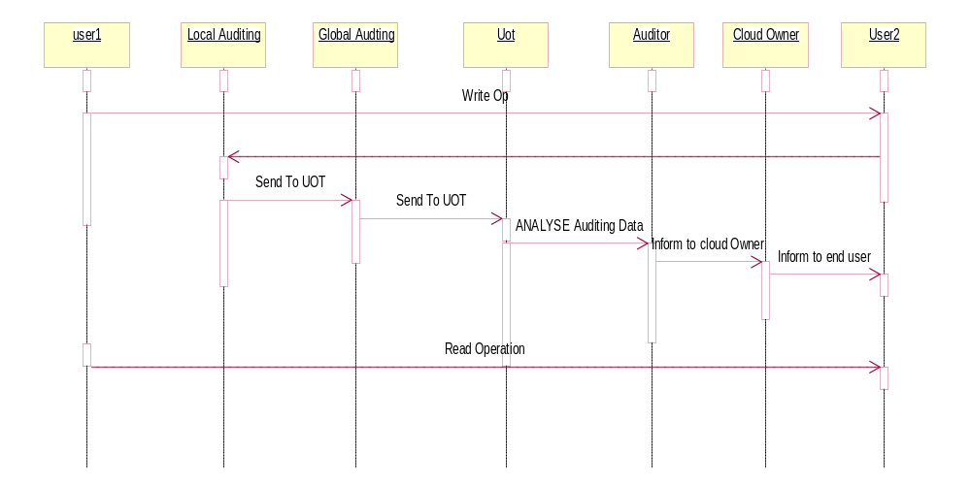

This diagram shows how processes operate with one another and in what order. In this project source node find a destination by using dynamic routing if an attacker interrupts in that node they send a positive reply and malicious may be send to destination node. And then by an alert message broadcast to all nodes about attacker.

COLLABORATION DIAGRAM

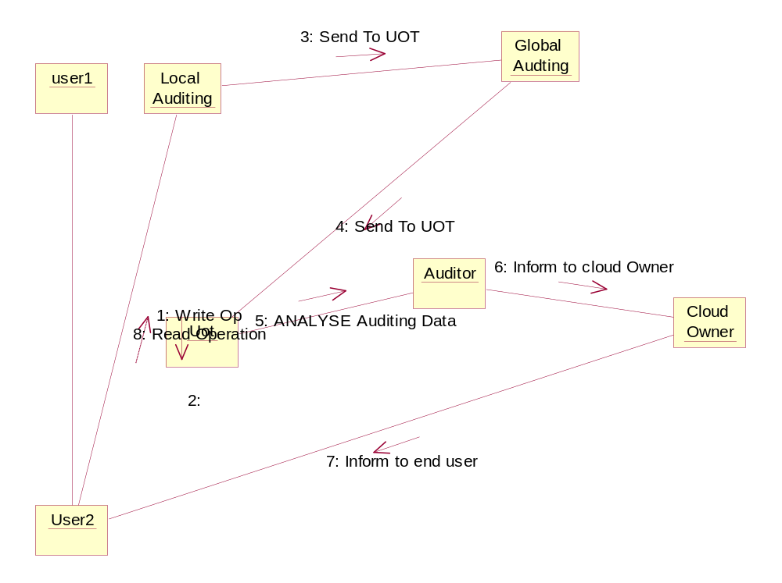

In this diagram source node find a destination by using dynamic routing if an attacker interrupts in that node they send a positive reply and malicious may be send to destination node. And then by an alert message broadcast to all nodes about attacker.

STATE DIAGRAM

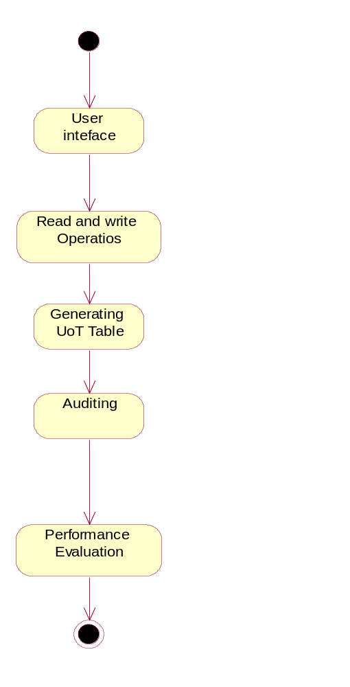
A state diagram is a type of diagram used in computer science and related fields to describe the behavior of systems. State diagrams require that the system described is composed of a finite number of states; sometimes, this is indeed the case, while at other times this is a reasonable abstraction. Here nodes are created then here tell about the maintaining node, then attacker interrupt and it causes network dysfunction.
ACTIVITY DIAGRAM

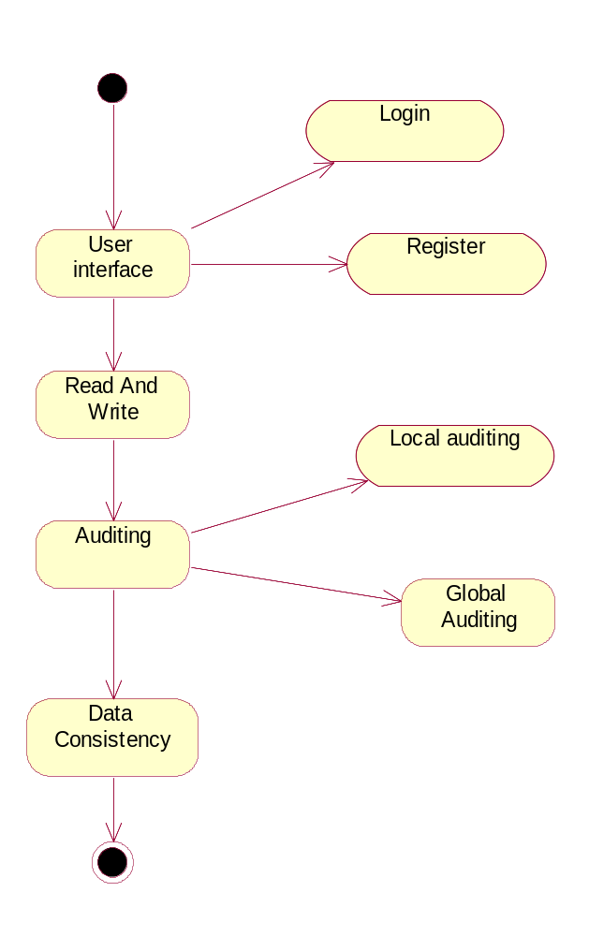
In this diagram first we have to create a network and path selection, the path that is dynamic at that attacker will interrupt in that network after attacker interrupt our system then we detect the attacker and prevent network. In this diagram represents the behavior of path selection and attacker.

COMPONENT DIAGRAM

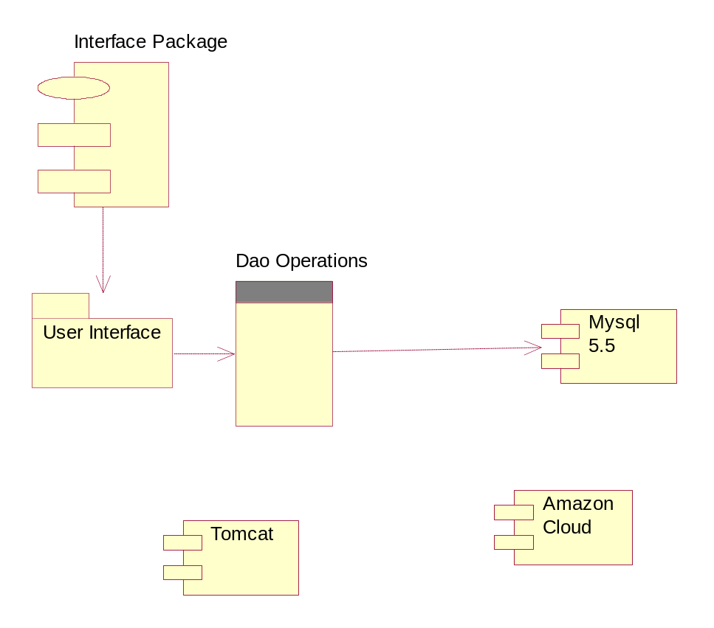

This diagram depicts how components are wired together to form larger components Java pack consists of number of nodes, in detection pack we detect the attack and prevent network.

DATA FLOW DIAGRAM

Level-0
User
Login Validate
True
Do Read and Write Operation
UOT

Level-1
AUDITING
Local Auditing
Global Auditing

AUDITING Data

In this diagram we create a node, if node can send a message to another node at that time this network make a dynamic path selection, thus make a path selection for sending information to destination node. Every node has a neighbor node information and destination distance and send to receiver. At last the path have been select and send to receiver.

E-R DIAGRAM
Auditing Information
User
Name
E-mail id
Password
Auditor
HAS
Local Vector
Global Vector

Here sender and receiver is an entity and then ipaddress, name and port are all attributes, then diamond box represents the relationship between the sender and receiver. This diagram illustrates the relationship between database and entity

SYSTEM ARCHITECTURE

Cloud
Register
Login
If existing user
OTP & Key
HAS
LOCAL AUDITNG
GLOBAL AUDITING
Cloud
If Consistency provided
Do READ and WRITE Operation on data
Informed to data owner


In our proposed system we have been proposed a HAS technique for auditing. Now days cloud is essentially a large scale distributed system where each piece of data is replicated on multiple distributed servers to achieve high availability and high performance. We first review the consistency models in distributed systems. As a standard textbook, proposed two classes of consistency models: data-centric consistency and client-centric consistency. Data-centric consistency model considers the internal state of a storage system, i.e., how updates flow through the system and what guarantees the system can provide with respect to updates. However, to a customer, it really does not matter whether or not a storage system internally contains any stale copies. As long as no stale data is observed from the client’s point of view, the customer is satisfied.

FUTURE ENHANCEMENT
Our Future With the our model, the users can assess the quality of cloud services and choose a right CSP among various candidates, e.g., the least expensive one that still provides adequate consistency for the users’ applications. For our future work, we will conduct a thorough theoretical study of consistency models in cloud computing. In our further work we have to achieve strong consistency in following manner In contrast, Eric Brewer posited that CAP is often taken to preclude consistency for services running in the highly elastic first tier of a modern cloud computing system. These services are typically required to be stateless or to maintain only soft-state (cached data), and must be responsive even if inner-tier services are temporarily inaccessible. CAP, in this sense, uses "A" to mean immediately responsive, and "P" to mean "even if a failure prevents the first-tier service from connecting to some needed resource". In effect, we sacrifice consistency to gain faster responses in a more scalable manner.

ADVANTAGE

- Optimization of task’s resource allocation Maximized resource utilization based on HAS very low expansive to achieve.
- Auditing consistency on a worldwide scale we can achieve to be connected with multiple cloud servers..

CONCLUSION
Currently, SNA users are often faced with incomplete and skewed SN data sets because of missing cultural elements. In this paper, we present a generic approach that can be used to systematically model cultural influences and infuse them into SNs.

REFERENCE OR BIBLIOGRAPHY
[1] M. Armbrust, A. Fox, R. Griffith, A. Joseph, R. Katz, A. Konwinski, G. Lee, D. Patterson, A. Rabkin, I. Stoica, et al., “A view of cloud computing,” Commun. ACM, vol. 53, no. 4, 2010.
[2] P. Mell and T. Grance, “The NIST definition of cloud computing (draft),” NIST Special Publication 800-145 (Draft), 2011.
[3] E. Brewer, “Towards robust distributed systems,” in Proc. 2000 ACM PODC.
[4] ——, “Pushing the CAP: strategies for consistency and availability,” Computer, vol. 45, no. 2, 2012.
[5] M. Ahamad, G. Neiger, J. Burns, P. Kohli, and P. Hutto, “Causal memory: definitions, implementation, and programming,” Distributed Computing, vol. 9, no. 1, 1995.
[6] W. Lloyd, M. Freedman, M. Kaminsky, and D. Andersen, “Don’t settle for eventual: scalable causal consistency for wide-area storage with COPS,” in Proc. 2011 ACM SOSP.
[7] E. Anderson, X. Li, M. Shah, J. Tucek, and J. Wylie, “What consistency does your key-value store actually provide,” in Proc. 2010 USENIX HotDep.
[8] C. Fidge, “Timestamps in message-passing systems that preserve the partial ordering,” in Proc. 1988 ACSC.
[9] W. Golab, X. Li, and M. Shah, “Analyzing consistency properties for fun and profit,” in Proc. 2011 ACM PODC.
[10] A. Tanenbaum and M. Van Steen, Distributed Systems: Principles and Paradigms. Prentice Hall PTR, 2002.

